How to creat playlist on F20 player?

1. Turn on F20 audio player, set it to USB mode:

Enter F20 player -> system setting -> USB mode, here please choose USB.

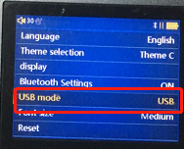

1. Use USB cable connect F20 player with computer;
2. Install M3U software on your computer:

3.1 Download and unzip the file “M3U” to your computer;

3.2 Double left click “M3U Dropper, exe” on your computer, you’ll get as below:

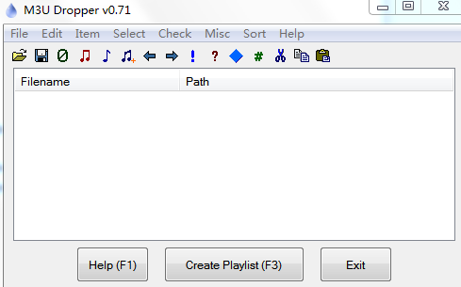

1. Drag music from F20 player to M3U as below, and click “create playlist”;

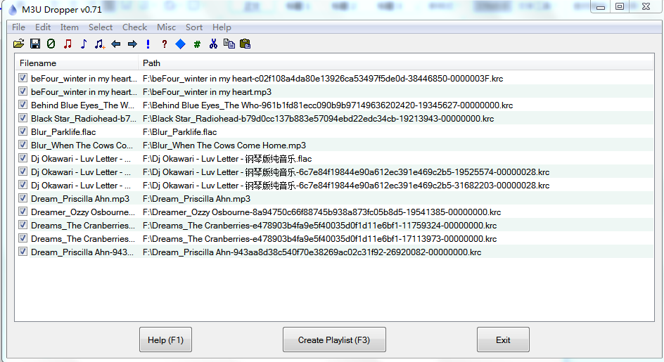

1. There will pop up a window asking where to save, please choose F20 player to save, you can edit name here;
2. When next window pops up, please click “Yes”, and disconnect player from your computer;

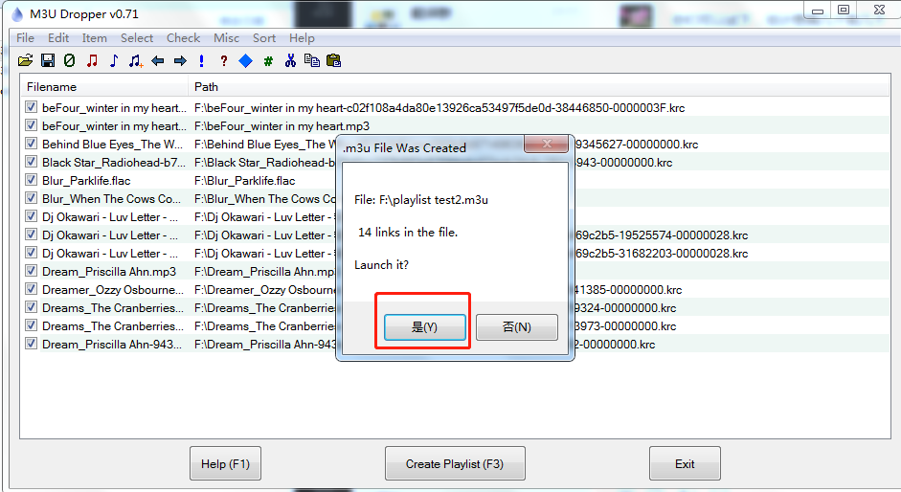

1. You can find your playlist listing on player:

Enter your F20 player -> explorer -> TF card, here you can find the playlist you created.

*Shall you have any other question about the operation issue, please freely contact us: help@surfans.net*